SALVI · AUTOMATION INTERN — ROUND 2 BUILD EXERCISE
Executive Oracle
Approach & Architecture
Kadhiravan Gopal

Overview
Executive Oracle is a small web app built for the round-2 exercise: it answers the three assigned questions using only the information in Salvi's two Executive House interview transcripts, cites which transcript (and roughly where) each answer came from, and says so plainly when a topic isn't covered rather than guessing. It's built as agentic RAG — retrieval-augmented generation with an actual decision loop in front of it, not a single prompt stuffed with context.

Approach
- Ingestion. Each PDF is parsed into speaker turns, keeping the inline [HH:MM:SS] timestamps and page numbers, then chunked with overlap and embedded locally with FastEmbed (no API call for embeddings) into a Qdrant vector store.
- Agent. A LangGraph graph runs every question through rewrite query → vector retrieval → LLM relevance grading → grounded answer (Gemini Flash). If nothing relevant comes back, it automatically rewrites the query and retries once; if there's still no evidence, it answers “This wasn't covered in the provided transcripts” instead of guessing — a code path, not a prompt request.
- Citations. Structured model output forces every claim to carry an inline [n] marker tied to an exact chunk. The References panel shows which transcript, which speaker, the approximate timestamp, the page, and a verbatim supporting quote for each one.
- Session-scoped knowledge base. Every session starts completely empty and owns exactly the PDFs uploaded into it — nothing is shared or preloaded across sessions, and there's no built-in shortcut for any specific file, including the two provided transcripts. You add what you want a session to know about, and a different session can never see it.
- App. React chat UI (the 3 assigned questions are one-click presets, multiple PDFs can be added at once) with a FastAPI backend; sessions, messages, and per-answer citations persist in SQLite.
Why this design. Retrieval keeps every answer auditable back to a source line. The grading step filters out banter and mic-check portions of the transcripts before they ever reach the answering model. The refusal path makes “don't guess” a structural guarantee rather than a prompt hint. And session-level isolation means this scales past two fixed transcripts into a real multi-project tool — closer to what the CEO Oracle project would need.

Architecture
Uploading a PDF writes chunks into Qdrant tagged with that session's id. Asking a question runs the LangGraph agent, which can only ever read chunks carrying that same id back out. A different session's uploads sit in the same collection but are structurally invisible — the diagram below traces both paths end to end.
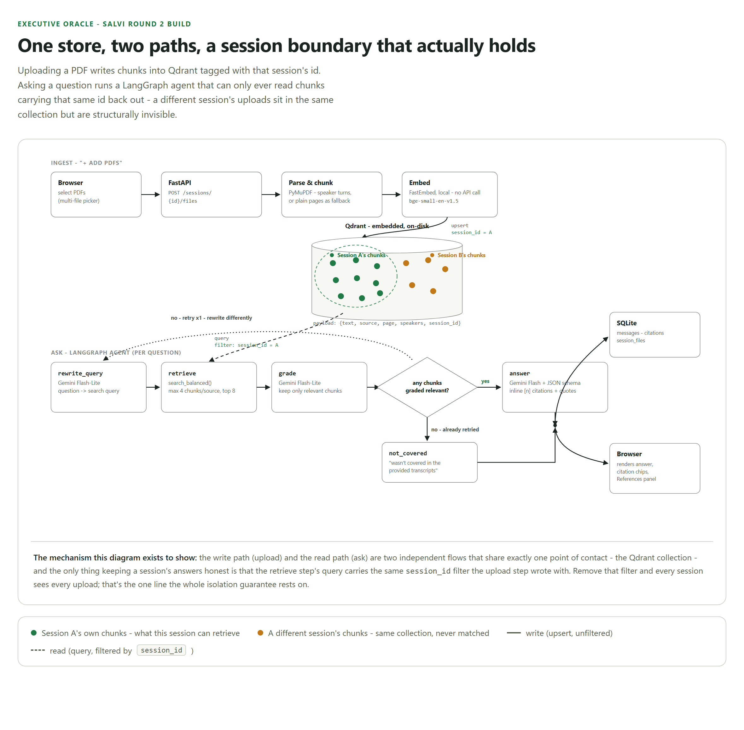
Figure 1. The write path (upload) and the read path (ask) share exactly one point of contact — the Qdrant collection. The only thing keeping a session's answers honest is that the retrieve step's query carries the same session_id filter the upload step wrote with.

The three assigned questions
- What's one piece of advice this executive gives about running a business?
- What challenge, mistake, or setback do they mention facing?
- What's a turning point or unexpected moment they mention in their career?
All three are available as one-click presets once a session's transcripts are loaded. Free-form questions work the same way, including off-topic ones — used to demonstrate the refusal path in the accompanying video.

Demo video
A short screen recording (under 5 minutes) showing the app running and producing answers to all three questions, plus the refusal path on an off-topic question, is attached / linked here: https://drive.google.com/file/d/1FhCUeQlvOQ62OzNDmPvd_O5gBG9qkZrI/view?usp=sharing

